**Express.js 20 program Examples**

**Q.1. What is Expressjs?**

**Ans :-**  Express is a node js web application framework that provides broad features for building web and mobile applications.

**Used :-**  to build a single page, multipage, and hybrid web application.

**Example 1 :-** **basic_express.js**

var express = require('express');

var app = express();

app.get('/', function (req, res) {

res.send('Welcome to JavaTpoint!');

});

var server = app.listen(8000, function () {

var host = server.address().address;

var port = server.address().port;

console.log('Example app listening at http://%s:%s', host, port);

});

**Command Prompt :-**

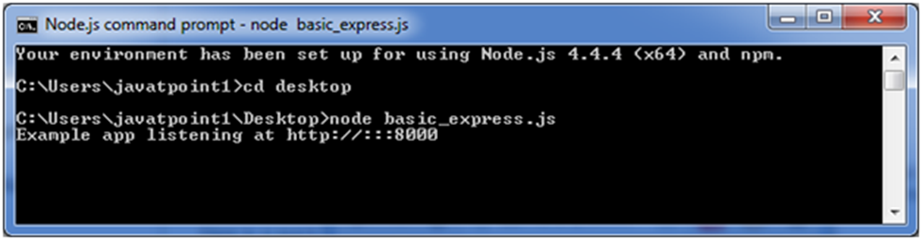

**Output :-**

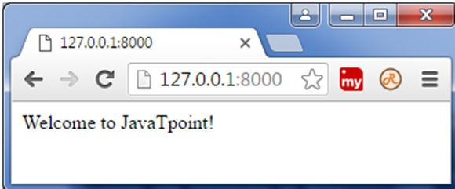

**Example2 :-** **Express.js GET Method**

Get method facilitates you to send only limited amount of data because data is sent in the header. It is not secure because data is visible in URL bar.

**File: index.html**

<html>

<body>

<form action="http://127.0.0.1:8081/process_get" method="GET">

First Name: <input type="text" name="first_name"> <br>

Last Name: <input type="text" name="last_name">

<input type="submit" value="Submit">

</form>

</body>

</html>

**File: get_example1.js**

var express = require('express');

var app = express();

app.use(express.static('public'));

app.get('/index.html', function (req, res) {

res.sendFile( __dirname + "/" + "index.html" );

})

app.get('/process_get', function (req, res) {

response = {

first_name:req.query.first_name,

last_name:req.query.last_name

};

console.log(response);

res.end(JSON.stringify(response));

})

var server = app.listen(8000, function () {

var host = server.address().address

var port = server.address().port

console.log("Example app listening at http://%s:%s", host, port)

})

**Command Prompt :-**

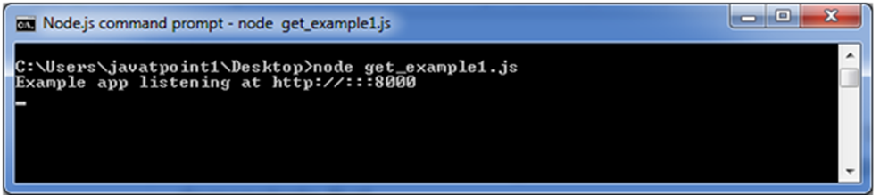

Open the page index.html and fill the entries:

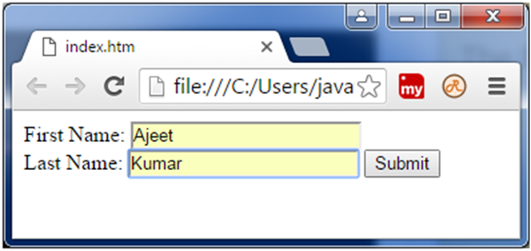

Now, you get the data in JSON format.

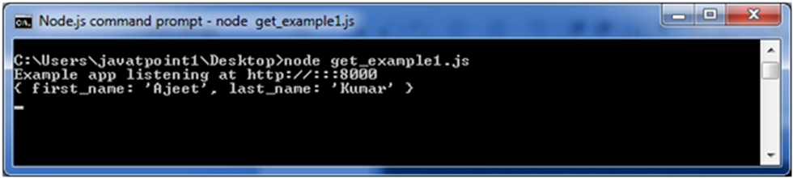

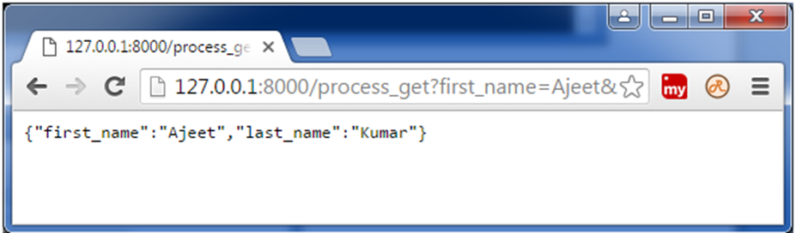

**Example 3:- Express.js GET Method**

**Fetch data in paragraph format**

**File: index.html**

<html>

<body>

<form action="http://127.0.0.1:8000/get_example2" method="GET">

First Name: <input type="text" name="first_name"/> <br/>

Last Name: <input type="text" name="last_name"/><br/>

<input type="submit" value="Submit"/>

</form>

</body>

</html>

**File: get_example2.js**

var express = require('express');

var app=express();

app.get('/get_example2', function (req, res) {

res.send('<p>Username: ' + req.query['first_name']+'</p><p>Lastname: '+req.query['last_name']+'</p>');

})

var server = app.listen(8000, function () {

var host = server.address().address

var port = server.address().port

console.log("Example app listening at http://%s:%s", host, port)

})



Open the page index.html and fill the entries:

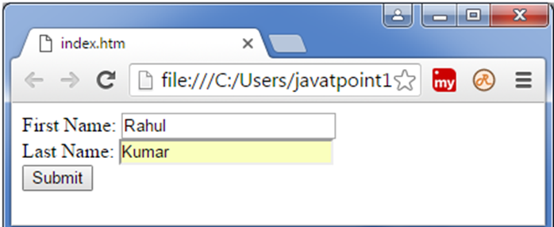

**Output:**

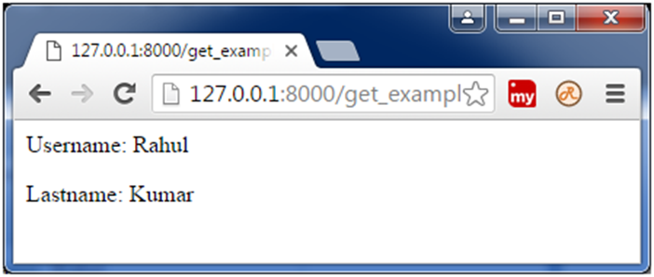

**Example 4 :-** **Express.js GET Method**

**File:index.html**

<!DOCTYPE html>

<html>

<body>

<form action="http://127.0.0.1:8000/get_example3">

<table>

<tr><td>Enter First Name:</td><td><input type="text" name="firstname"/><td></tr>

<tr><td>Enter Last Name:</td><td><input type="text" name="lastname"/><td></tr>

<tr><td>Enter Password:</td><td><input type="password" name="password"/></td></tr>

<tr><td>Sex:</td><td>

<input type="radio" name="sex" value="male"> Male

<input type="radio" name="sex" value="female">Female

</td></tr>

<tr><td>About You :</td><td>

<textarea rows="5" cols="40" name="aboutyou" placeholder="Write about yourself">

</textarea>

</td></tr>

<tr><td colspan="2"><input type="submit" value="register"/></td></tr>

</table>

</form>

</body>

</html>

**File: get_example.js**

var express = require('express');

var app=express();

app.get('/get_example3', function (req, res) {

res.send('<p>Firstname: ' + req.query['firstname']+'</p>

<p>Lastname: '+req.query['lastname']+'</p><p>Password: '+req.query['password']+'</p>

<p>AboutYou: '+req.query['aboutyou']+'</p>');

})

var server = app.listen(8000, function () {

var host = server.address().address

var port = server.address().port

console.log("Example app listening at http://%s:%s", host, port)

})

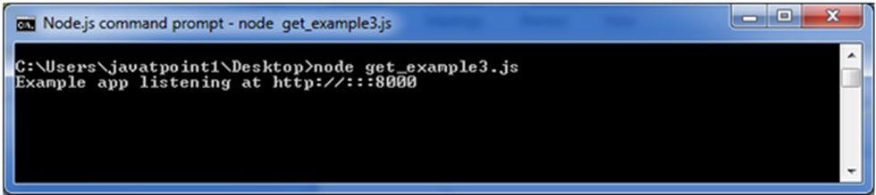

**Output :-**

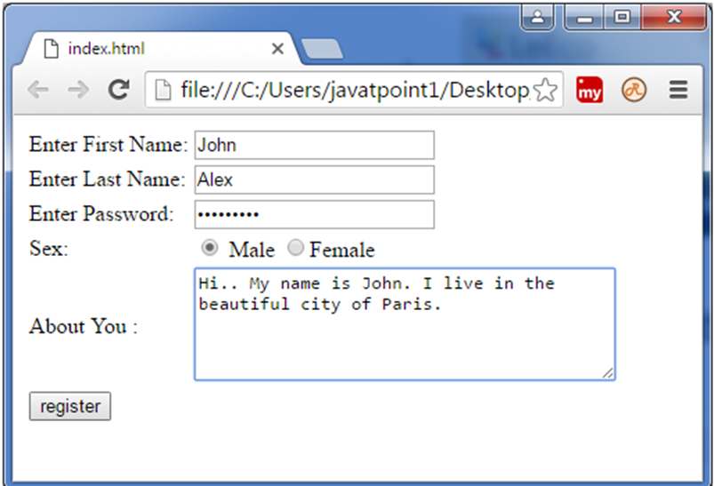

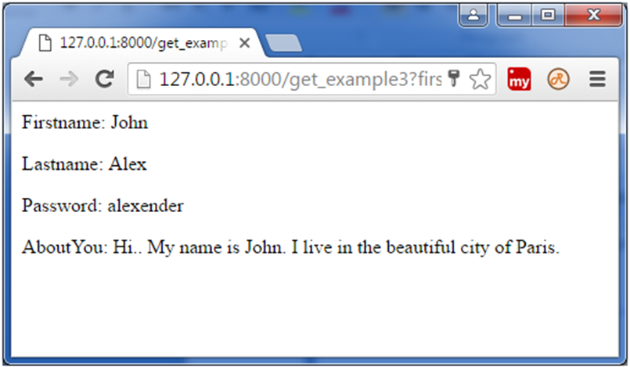

**Example 5 :-** **Express.js POST Request**

GET and POST both are two common HTTP requests used for building REST API's. POST requests are used to send large

**Fetch data in JSON format**

**File: Index.html**

<html>

<body>

<form action="http://127.0.0.1:8000/process_post" method="POST">

First Name: <input type="text" name="first_name"> <br>

Last Name: <input type="text" name="last_name">

<input type="submit" value="Submit">

</form>

</body>

</html>

**File: post_example1.js**

var express = require('express');

var app = express();

var bodyParser = require('body-parser');

// Create application/x-www-form-urlencoded parser

var urlencodedParser = bodyParser.urlencoded({ extended: false })

app.use(express.static('public'));

app.get('/index.html', function (req, res) {

res.sendFile( __dirname + "/" + "index.html" );

})

app.post('/process_post', urlencodedParser, function (req, res) {

// Prepare output in JSON format

response = {

first_name:req.body.first_name,

last_name:req.body.last_name

};

console.log(response);

res.end(JSON.stringify(response));

})

var server = app.listen(8000, function () {

var host = server.address().address

var port = server.address().port

console.log("Example app listening at http://%s:%s", host, port)

})

**Command Prompt :-**

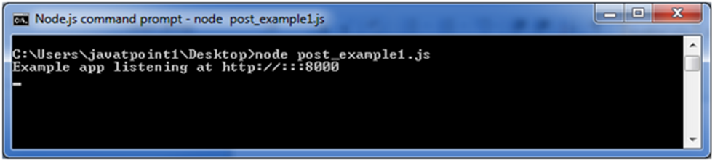

Open the page index.html and fill the entries:

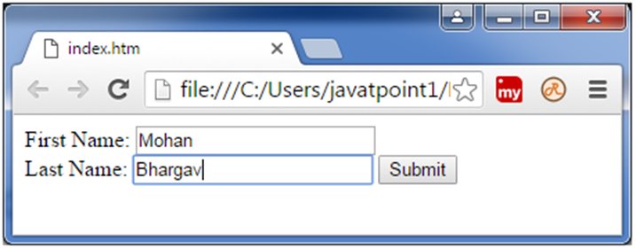

Now, you get the data in JSON format. Note: In the above picture, you 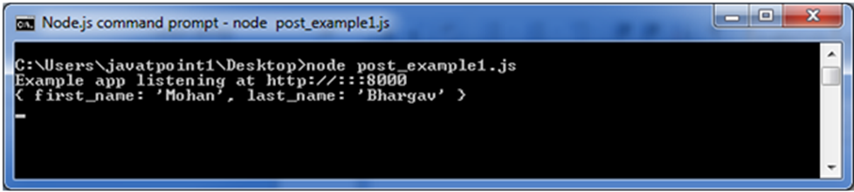

Note: In the above picture, you

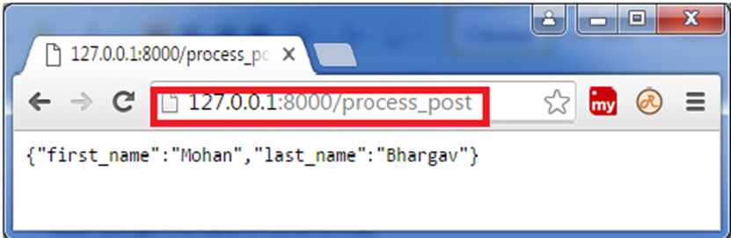

entries are not visible in the URL bar unlike GET method.

**Example 6 :-** **Express.js Routing**

Routing is made from the word route. It is used to determine the specific behavior of an application.

**File: routing_example.js**

var express = require('express');

var app = express();

app.get('/', function (req, res) {

console.log("Got a GET request for the homepage");

res.send('Welcome to JavaTpoint!');

})

app.post('/', function (req, res) {

console.log("Got a POST request for the homepage");

res.send('I am Impossible! ');

})

app.delete('/del_student', function (req, res) {

console.log("Got a DELETE request for /del_student");

res.send('I am Deleted!');

})

app.get('/enrolled_student', function (req, res) {

console.log("Got a GET request for /enrolled_student");

res.send('I am an enrolled student.');

})

// This responds a GET request for abcd, abxcd, ab123cd, and so on

app.get('/ab*cd', function(req, res) {

console.log("Got a GET request for /ab*cd");

res.send('Pattern Matched.');

})

var server = app.listen(8000, function () {

var host = server.address().address

var port = server.address().port

console.log("Example app listening at http://%s:%s", host, port)

})

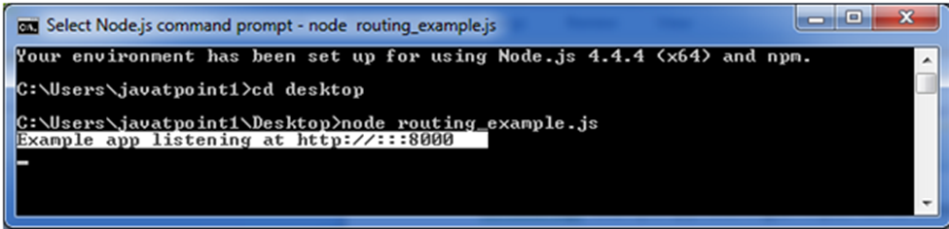

You see that server is listening.

Now, you can see the result generated by server on the local host <http://127.0.0.1:8000>

**Output:**

This is the homepage of the example app.

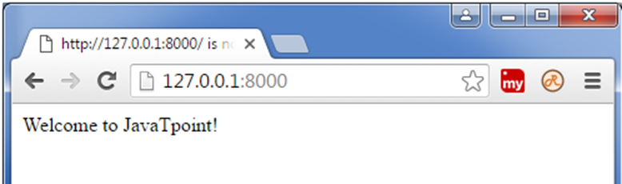

**Note:** The Command Prompt will be updated after one successful response.

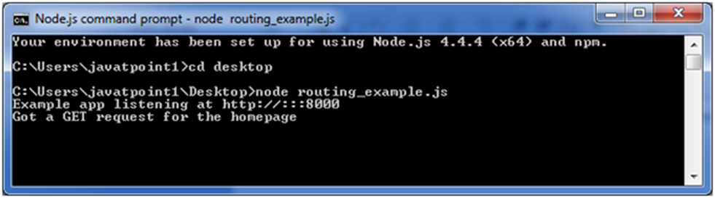

You can see the different pages by changing routes. <http://127.0.0.1:8000/enrolled_student>

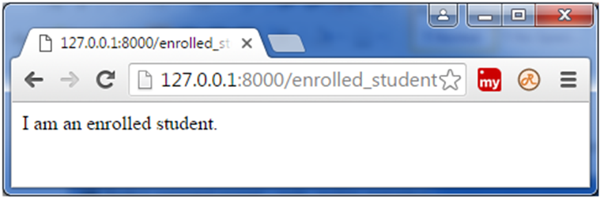

**Updated command prompt:**

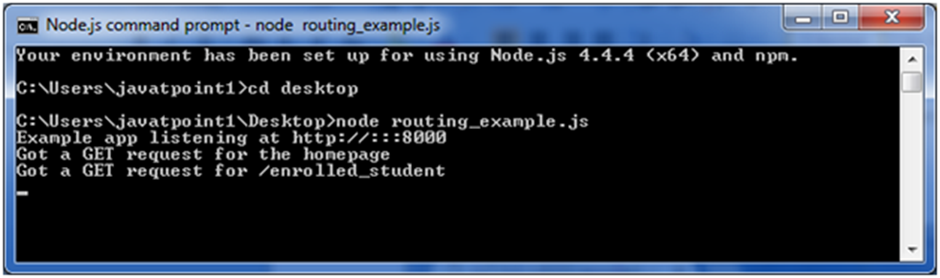

This can read the pattern like abcd, abxcd, ab123cd, and so on.

Next route[**http://127.0.0.1:8000/abcd**](http://127.0.0.1:8000/abcd)

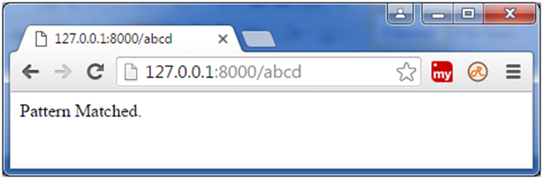

Next route[**http://127.0.0.1:8000/ab12345cd**](http://127.0.0.1:8000/ab12345cd)



**Updated command prompt:**

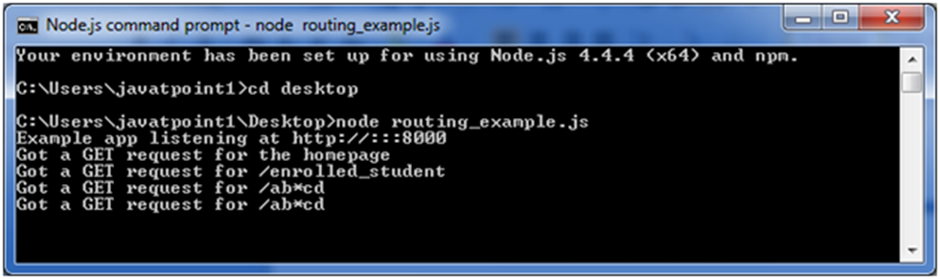

**Example 7 :-** **Express.js Cookies**

Cookies are small piece of information i.e. sent from a website and stored in user's web browser when user browses that website.

**File: cookies_example.js**

var express = require('express');

var cookieParser = require('cookie-parser');

var app = express();

app.use(cookieParser());

app.get('/cookieset',function(req, res){

res.cookie('cookie_name', 'cookie_value');

res.cookie('company', 'javatpoint');

res.cookie('name', 'sonoo');

res.status(200).send('Cookie is set');

});

app.get('/cookieget', function(req, res) {

res.status(200).send(req.cookies);

});

app.get('/', function (req, res) {

res.status(200).send('Welcome to JavaTpoint!');

});

var server = app.listen(8000, function () {

var host = server.address().address;

var port = server.address().port;

console.log('Example app listening at http://%s:%s', host, port);

});

**Command Prompt :-**

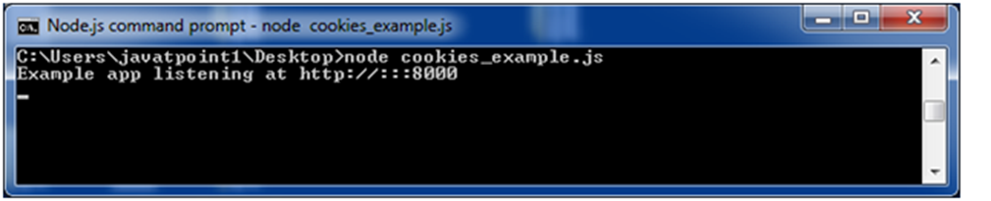

**Output:-**

Open the page **http://127.0.0.1:8000/** on your browser:

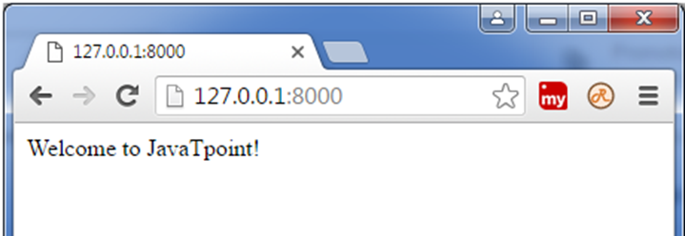

**Set cookie:**

Now open **http://127.0.0.1:8000/cookieset** to set the cookie:

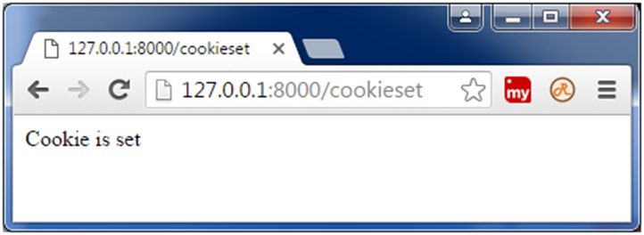

**Get cookie:**

Now open **http://127.0.0.1:8000/cookieget** to get the cookie:

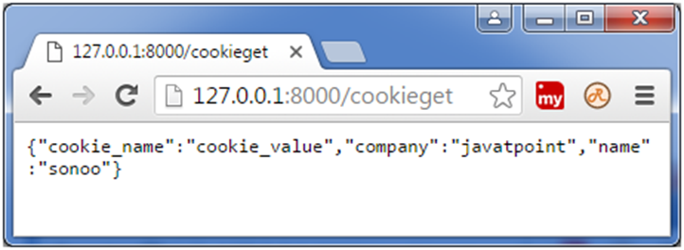

**Example 8 :- Express.js File Upload**

Let's take an example to demonstrate file upload in Node.js. Here, we are using the middleware 'multer'.

Create a folder "jtp file upload" having the following files:

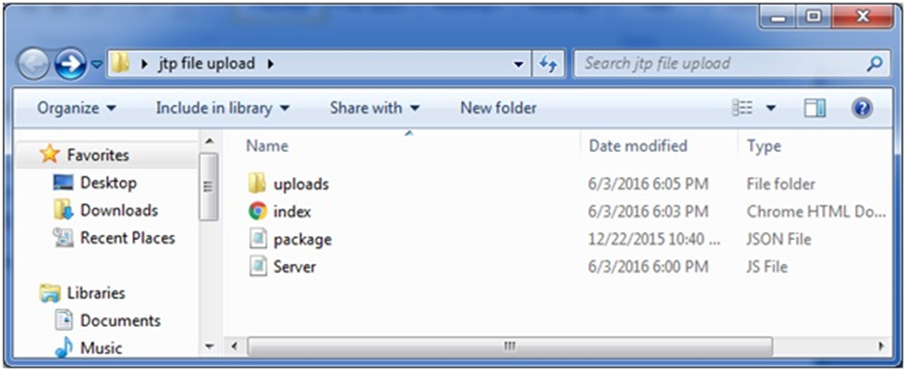

• **uploads:** It is an empty folder i.e. created to store the uploaded images.

• **package:** It is JSON file, having the following data:

**File: package.json**

{

"name": "file_upload",

"version": "0.0.1",

"dependencies": {

"express": "4.13.3",

"multer": "1.1.0"

},

"devDependencies": {

"should": "~7.1.0",

"mocha": "~2.3.3",

"supertest": "~1.1.0"

}

}

**File: index.html**

<html>

<head>

<title>File upload in Node.js by Javatpoint</title>

<script src="http://ajax.googleapis.com/ajax/libs/jquery/1.7.1/jquery.min.js"></script>

<script src="http://cdnjs.cloudflare.com/ajax/libs/jquery.form/3.51/jquery.form.min.js"></script>

<script>

$(document).ready(function() {

$('#uploadForm').submit(function() {

$("#status").empty().text("File is uploading...");

$(this).ajaxSubmit({

error: function(xhr) {

status('Error: ' + xhr.status);

},

success: function(response) {

console.log(response)

$("#status").empty().text(response);

}

});

return false;

});

});

</script>

</head>

<body>

<h1>Express.js File Upload: by Javatpoint</h1>

<form id="uploadForm" enctype="multipart/form-data" action="/uploadjavatpoint" method="post">

<input type="file" name="myfile" /><br/><br/>

<input type="submit" value="Upload Image" name="submit"><br/><br/>

<span id="status"></span>

</form>

</body>

</html>

**File: server.js**

var express = require("express");

var multer = require('multer');

var app = express();

var storage = multer.diskStorage({

destination: function (req, file, callback) {

callback(null, './uploads');

},

filename: function (req, file, callback) {

callback(null, file.originalname);

}

});

var upload = multer({ storage : storage}).single('myfile');

app.get('/',function(req,res){

res.sendFile(__dirname + "/index.html");

});

app.post('/uploadjavatpoint',function(req,res){

upload(req,res,function(err) {

if(err) {

return res.end("Error uploading file.");

}

res.end("File is uploaded successfully!");

});

});

app.listen(2000,function(){

console.log("Server is running on port 2000");

});

To install the **package.json**, execute the following code:

npm install

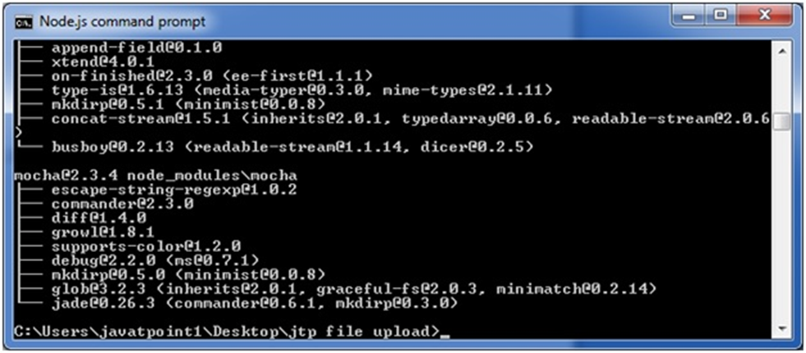

It will create a new folder "node_modules" inside the "jtp file upload" folder.

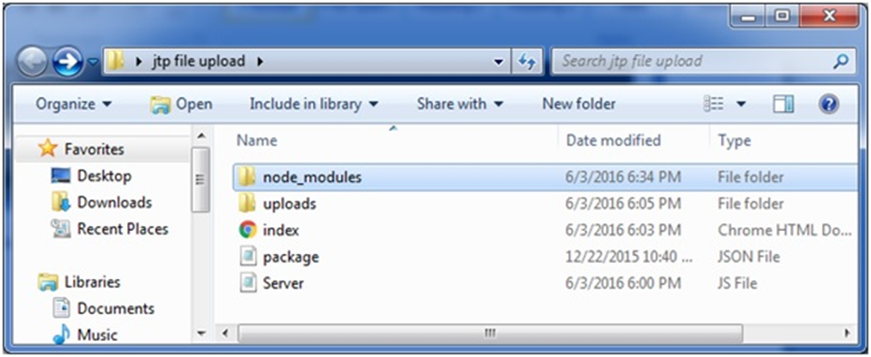

Dependencies are installed. Now, run the server:

node server.js

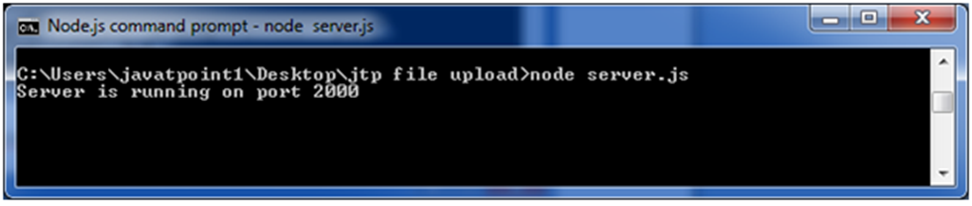

Open the local page http://127.0.0.1:2000/ to upload the images.

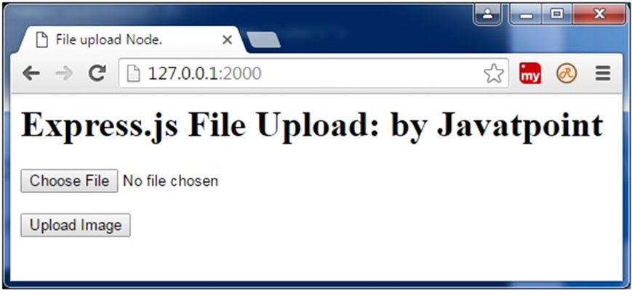

Select an image to upload and click on "Upload Image" button.

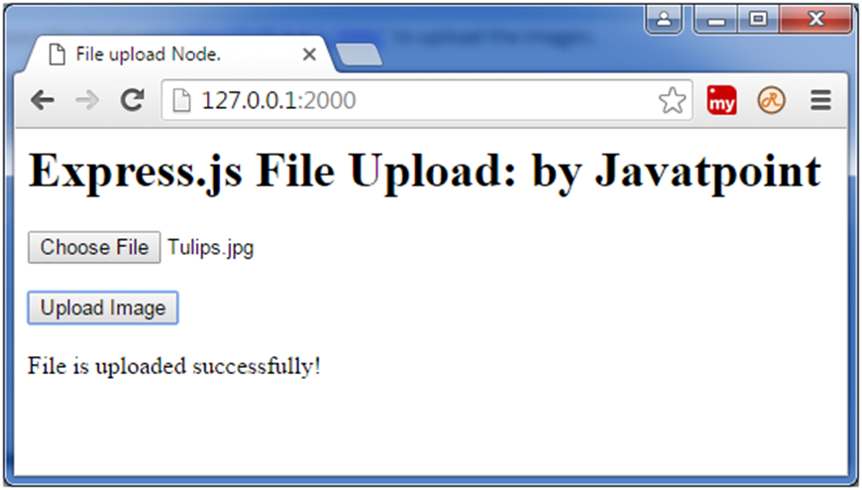

Here, you see that file is uploaded successfully. You can see the uploaded file in the "Uploads" folder.

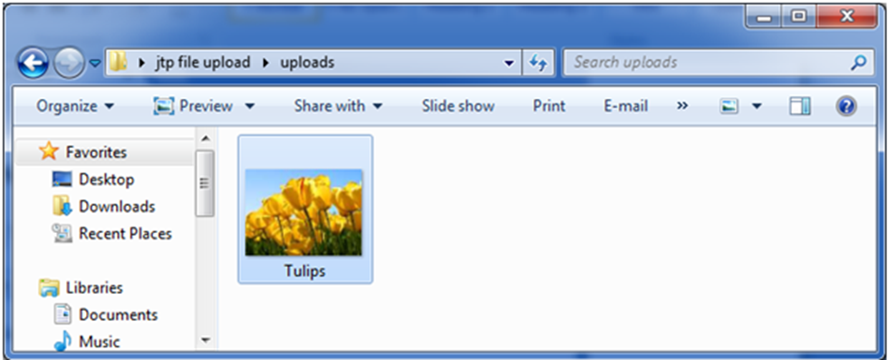

**Example 9 :-** **Express.js Middleware**

Express.js Middleware are different types of functions that are invoked by the Express.js routing layer before the final request handler.

**File: simple_express.js**

var express = require('express');

var app = express();

app.get('/', function(req, res) {

res.send('Welcome to JavaTpoint!');

});

app.get('/help', function(req, res) {

res.send('How can I help You?');

});

var server = app.listen(8000, function () {

var host = server.address().address

var port = server.address().port

console.log("Example app listening at http://%s:%s", host, port)

})

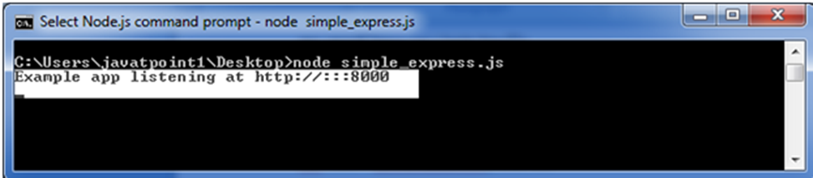

You see that server is listening.

Now, you can see the result generated by server on the local host [**http://127.0.0.1:8000**](http://127.0.0.1:8000)

**Output:**

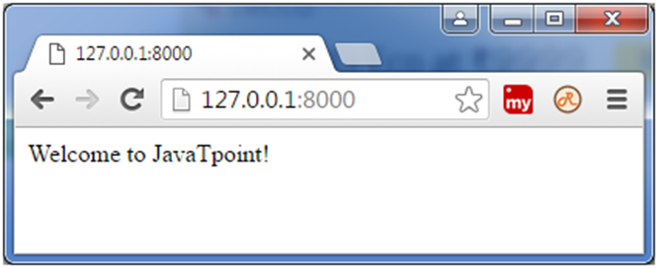

**Let's see the next page:** [**http://127.0.0.1:8000/help**](http://127.0.0.1:8000/help)

**Output:-**

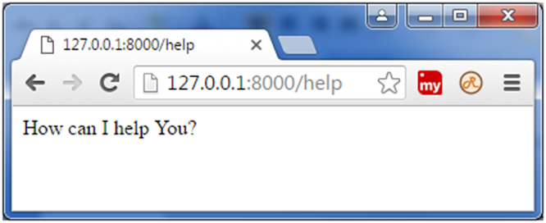

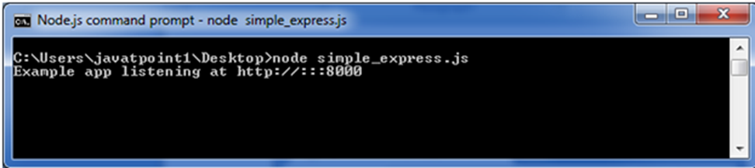

**Note**: You see that the command prompt is not changed. Means, it is not showing any record of the GET request although a GET request is processed in the http://127.0.0.1:8000/help page.

**Example 10:- Use of Express.js Middleware**

**File: simple_middleware.js**

var express = require('express');

var app = express();

app.use(function(req, res, next) {

console.log('%s %s', req.method, req.url);

next();

});

app.get('/', function(req, res, next) {

res.send('Welcome to JavaTpoint!');

});

app.get('/help', function(req, res, next) {

res.send('How can I help you?');

});

var server = app.listen(8000, function () {

var host = server.address().address

var port = server.address().port

console.log("Example app listening at http://%s:%s", host, port)

})

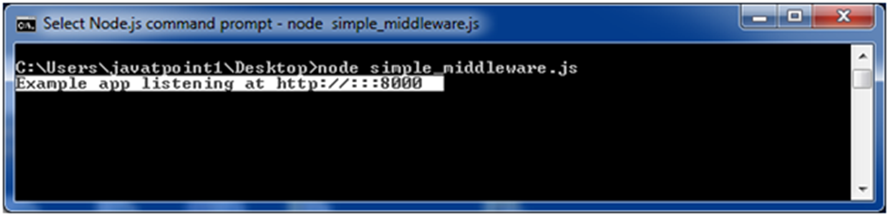

You see that server is listening.

Now, you can see the result generated by server on the local host http://127.0.0.1:8000

**Output:**

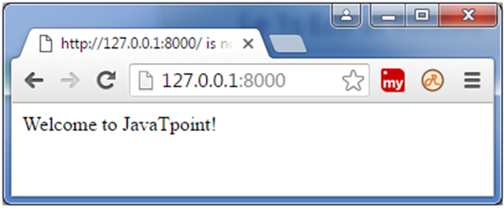

You can see that output is same but command prompt is displaying a GET result.

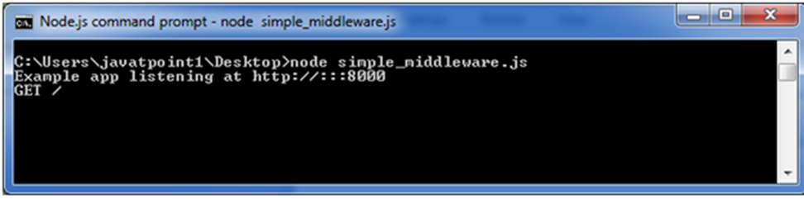

Go to <http://127.0.0.1:8000/help>

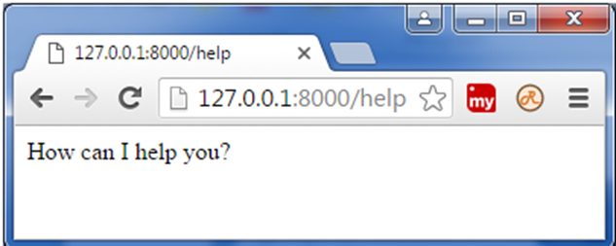

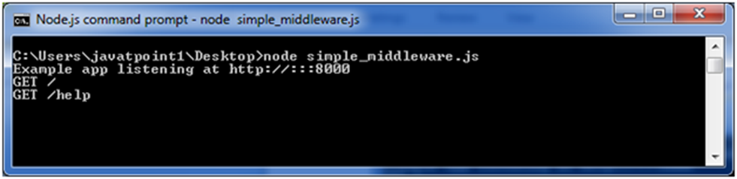

As many times as you reload the page, the command prompt will be updated.

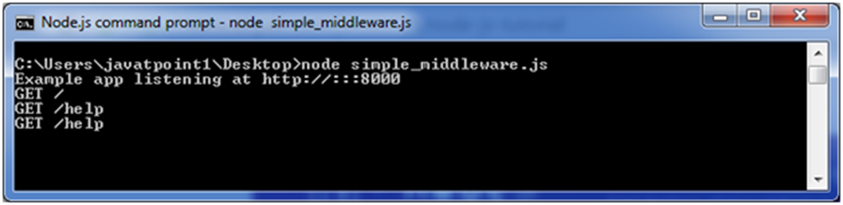

Note: In the above example next() middleware is used.

**Example 11:-** **Express.js Scaffolding**

**What is scaffolding**

**Ans:** Scaffolding is a technique that is supported by some MVC frameworks.

npm install express-scaffold

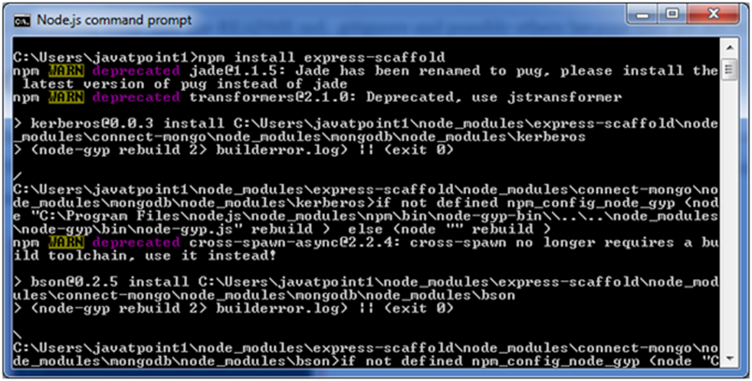

After this step, execute the following command to install express generator:

npm install -g express-generator

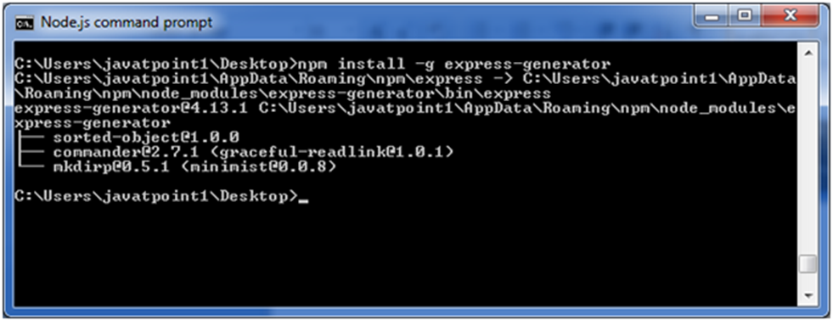

First create a directory named myapp. Create a file named app.js in the myapp directory having the following code:

var express = require('express');

var app = express();

app.get('/', function (req, res) {

res.send('Welcome to JavaTpoint!');

});

app.listen(8000, function () {

console.log('Example app listening on port 8000!');

});

Open Node.js command prompt, go to myapp and run npm init command (In my case, I have created myapp folder on desktop)



Fill the entries and press enter.

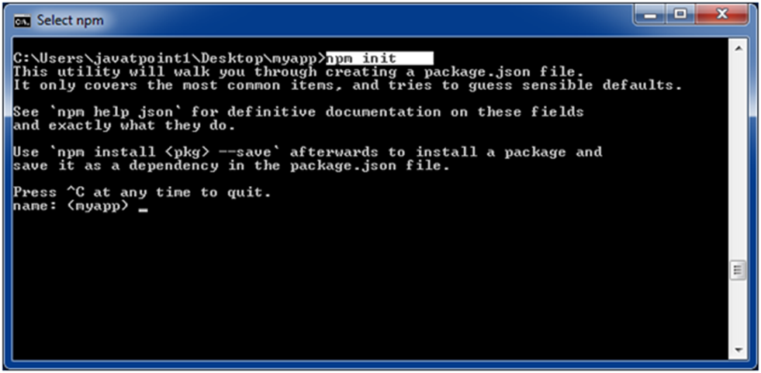

It will create a package.json file in myapp folder and the data is shown in JSON format.

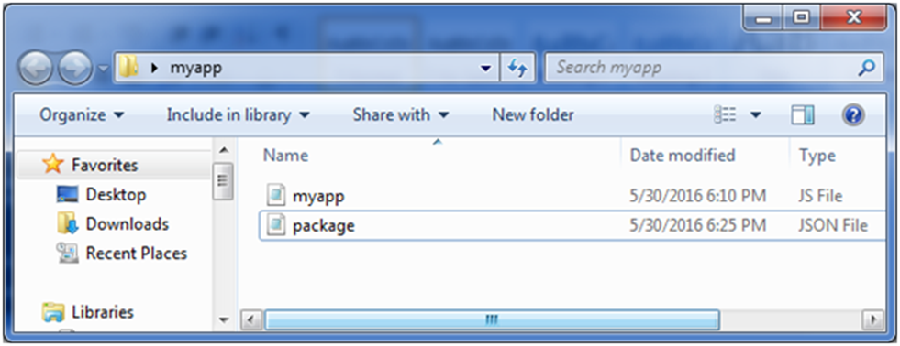

**Output:**

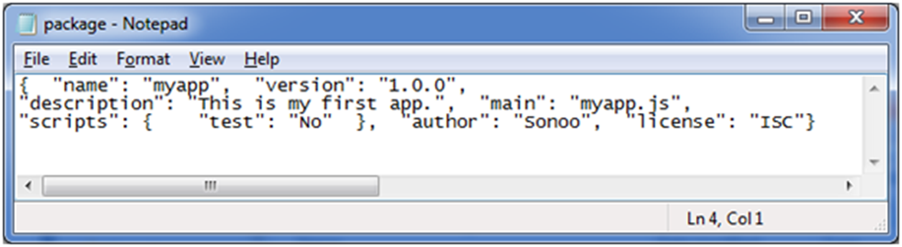

**Example 12 : Hello World in Express.js**

const express = require('express')

const app = express()

const port = 3000

app.get('/', (req, res) => {

res.send('Hello World!')

})

app.listen(port, () => {

console.log(`Example app listening on port ${port}`)

})

**Run the app with the following command:**

$ node app.js

**Output:**

Hello World!

**Example 13:** **Filename: index.js**

const express = require('express');

const app = express();

const PORT = 3000;

app.use(express.text());

app.post('/', function (req, res) {

console.log(req.body);

res.end();

})

app.listen(PORT, function (err) {

if (err) console.log(err);

console.log("Server listening on PORT", PORT);

});

**Command Prompt:-**

npm install express

**Run the index.js file using the below command:**

node index.js

**Output:-**

Server listening on PORT 3000

**Express.js Request Object Properties:**

**Example 14:-**

app.get('/example', (req, res) => {

// Accessing properties of the request object

const method = req.method; // HTTP method of the request (e.g., GET, POST)

const url = req.url; // URL of the request

const headers = req.headers; // HTTP headers of the request

const params = req.params; // URL parameters

const query = req.query; // Query parameters

const body = req.body; // Request body (parsed by body-parser middleware if used)

const cookies = req.cookies; // Cookies sent with the request

const ip = req.ip; // IP address of the client

// Do something with the request properties

// ...

res.send('Response sent!');

});

**Example 15:- req.app**

This is used to hold a reference to the instance of the express application that is using the middleware.

const express = require('express');

const app = express();

app.get('/example', (req, res) => {

// Access the application object using req.app

const appInstance = req.app;

// Perform actions with the application object

appInstance.set('title', 'My Express App');

const appTitle = appInstance.get('title');

res.send(`Application title: ${appTitle}`);

});

app.listen(3000, () => {

console.log('Server is running on port 3000');

});

**Example 16:- req.baseurl**

It specifies the URL path on which a router instance was mounted.

const express = require('express');

const app = express();

const baseURL = '/api'; // Define your base URL here

// Define your routes

app.get(baseURL + '/users', (req, res) => {

// Handle GET /api/users

// ...

});

app.post(baseURL + '/users', (req, res) => {

// Handle POST /api/users

// ...

});

// ...

// Start the server

app.listen(3000, () => {

console.log('Server is running on port 3000');

});

**Example 17:- req.body**

It contains key-value pairs of data submitted in the request body.

const express = require('express');

const app = express();

// Middleware to parse the request body

app.use(express.json());

// Route handler

app.post('/example', (req, res) => {

const requestBody = req.body;

// Do something with the data in req.body

// ...

res.send('Request body received');

});

app.listen(3000, () => {

console.log('Server started on port 3000');

});

**Example 18:- req.cookies**

When we use cookie-parser middleware, this property is an object that contains cookies sent by the request.

**1.Install cookie-parser using npm or yarn:**

npm install cookie-parser

**2.Require and set up the cookconst express = require('express');**

const express = require('express');

const cookieParser = require('cookie-parser');

const app = express();

app.use(cookieParser());

**3. Access the cookies using req.cookies in your route handlers:**

app.get('/example', (req, res) => {

const cookies = req.cookies;

// Access individual cookies by their names

const cookieValue = req.cookies.cookieName;

// ... do something with the cookies

res.send('Cookies received');

});

**Example 19:- req.fresh**

It specifies that the request is "fresh." it is the opposite of req.stale.

app.get('/data', function(req, res) {

// Check if the data is fresh

if (req.fresh) {

// The client already has the latest version of the resource

res.status(304).end(); // Not Modified

} else {

// The resource has been modified or it's the first request

// Send the updated resource

res.json({ data: 'updated data' });

}

});

**Example 20:- req.hostname**

It contains the hostname from the "host" http header.

const express = require('express');

const app = express();

app.get('/', (req, res) => {

const hostname = req.hostname;

res.send(`Hostname: ${hostname}`);

});

app.listen(3000, () => {

console.log('Server is running on port 3000');

});

**Example 21:- req.ip**

It specifies the remote IP address of the request.

const express = require('express');

const app = express();

app.get('/', (req, res) => {

const clientIp = req.ip;

res.send(`Your IP address is: ${clientIp}`);

});

app.listen(3000, () => {

console.log('Server started on port 3000');

});

**Example 22:- req.ips**

When the trust proxy setting is true, this property contains an array of IP addresses specified in the ?x-forwarded-for? request header.

const express = require('express');

const app = express();

app.set('trust proxy', true); // Enables trust for proxy headers

app.get('/', (req, res) => {

const clientIP = req.ip; // Client IP address

const proxyIPs = req.ips; // Array of proxy IP addresses

console.log('Client IP:', clientIP);

console.log('Proxy IPs:', proxyIPs);

res.send('Hello, World!');

});

app.listen(3000, () => {

console.log('Server listening on port 3000');

});

**Example 23:- req.originalurl**

This property is much like req.url; however, it retains the original request URL, allowing you to rewrite req.url freely for internal routing purposes.

const express = require('express');

const app = express();

app.get('/users', (req, res) => {

console.log(req.originalUrl); // Output: "/users?sort=desc"

res.send('User list');

});

app.listen(3000, () => {

console.log('Server listening on port 3000');

});

**Example 24:- req.params**

An object containing properties mapped to the named route ?parameters?. For example, if you have the route /user/:name, then the "name" property is available as req.params.name. This object defaults to {}.

**For example, consider the following route definition:**

app.get('/users/:id', (req, res) => {

const userId = req.params.id;

// Rest of the code...

});

**You can have multiple route parameters in a single URL, and they will be available in the req.params object using their respective names. For example:**

app.get('/users/:id/posts/:postId', (req, res) => {

const userId = req.params.id;

const postId = req.params.postId;

// Rest of the code...

});

**Example 25 :- req.path**

It contains the path part of the request URL.

const express = require('express');

const app = express();

app.get('/users/:id', (req, res) => {

console.log(req.path); // Outputs the path portion of the URL

// ... rest of the route handler logic

});

app.listen(3000, () => {

console.log('Server started on port 3000');

});

**Example 26:- req.protocol**

The request protocol string, "http" or "https" when requested with TLS.

const express = require('express');

const app = express();

app.get('/', (req, res) => {

const protocol = req.protocol;

res.send(`The current request protocol is ${protocol}`);

});

app.listen(3000, () => {

console.log('Server is running on port 3000');

});

**Example 27:- req.query**

An object containing a property for each query string parameter in the route.

const express = require('express');

const app = express();

// Define a route handler for GET requests to '/search'

app.get('/search', (req, res) => {

const query = req.query.query; // Access the value of 'query' parameter

const type = req.query.type; // Access the value of 'type' parameter

// Do something with the parameters

// ...

// Send a response back to the client

res.send('Query: ' + query + ', Type: ' + type);

});

// Start the server

app.listen(3000, () => {

console.log('Server listening on port 3000');

});

**Example 28 :- req.route**

The currently-matched route, a string.

app.get('/users/:id', (req, res) => {

console.log(req.route.path); // "/users/:id"

console.log(req.route.methods.GET); // true

// Your code logic...

});

**Example 29 :- req.secure**

A Boolean that is true if a TLS connection is established.

app.use((req, res, next) => {

if (req.secure) {

// The request was made over HTTPS, continue processing

next();

} else {

// Redirect HTTP requests to HTTPS

res.redirect('https://' + req.headers.host + req.url);

}

});

**Example 30:- req.signedcookies**

When using cookie-parser middleware, this property contains signed cookies sent by the request, unsigned and ready for use.

const express = require('express');

const cookieParser = require('cookie-parser');

const app = express();

// Middleware for parsing cookies

app.use(cookieParser('your-secret-key'));

// Route handler

app.get('/', (req, res) => {

// Accessing signed cookies

const signedCookieValue = req.signedCookies.cookieName;

// ...

});

app.listen(3000, () => {

console.log('Server is listening on port 3000');

});

**Example 31 :-req.stale**

It indicates whether the request is "stale," and is the opposite of req.fresh.

app.get('/data', (req, res) => {

// Check if the resource is stale

if (req.stale) {

// Resource is stale, send 304 Not Modified status

return res.sendStatus(304);

} else {

// Resource is fresh, send the updated data

return res.json({ message: 'Fresh data' });

}

});

**Example 32:-req.subdomains**

It represents an array of subdomains in the domain name of the request.

const express = require('express');

const app = express();

app.get('/', (req, res) => {

// Access the subdomains

const subdomains = req.subdomains;

// Do something with the subdomains

// ...

res.send('Hello, subdomains!');

});

app.listen(3000, () => {

console.log('Server is running on port 3000');

});

**Example 33:- req.xhr**

A Boolean value that is true if the request's "x-requested-with" header field is "xmlhttprequest", indicating that the request was issued by a client library such as jQuery

app.get('/data', (req, res) => {

if (req.xhr) {

// This is an AJAX request

res.send('AJAX request received');

} else {

// This is not an AJAX request

res.send('Non-AJAX request received');

}

});